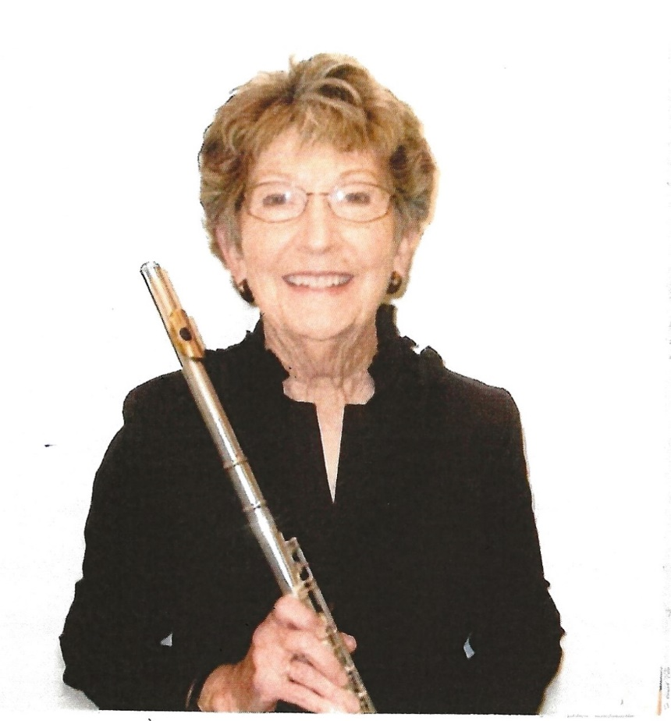
Karen King

Karen grew up in Pacific grove where 6 weeks of summer school music was offered to students in fourth through sixth grades. What an amazing opportunity to be exposed to all the instruments of the band and orchestra plus chorus! Professor Thomas Eagan from San Jose State University was her first inspiring teacher. He gave her six lessons each summer until she was able to study with Ray Fabrizio, a fabulous flutist and mentor. While working toward her A.A. Degree in Music at Monterey Peninsula College and playing in the flute section of the Monterey County Symphony, Karen met her future husband, David who was Section Leader in the Trombone section. Trombone and flute duets followed.

After earning her B.A. Degree in Music at San Jose State College, Karen received her Lifetime Teaching Credential for grades K-14 specializing in Music Education. While her two boys were young, she taught part-time at the Hartnell Conservatory of Music, Monterey Peninsula College, and Santa Catalina High School. Once her children were older, she took a full-time position with the Carmel Unified School District at Carmel Middle School. Her classes included three levels of Concert Band, Orchestra, Jazz Band and Beginning Instruments. Spring performances for her music students included visits to Carmel’s elementary schools and trips to music festivals.

Karen continues to be active in the local music scene, playing flute and piccolo with the Monterey County Pops! and chamber groups. Playing in ensembles with her music friends rounds out her musical life and is one of her most enjoyable activities.

