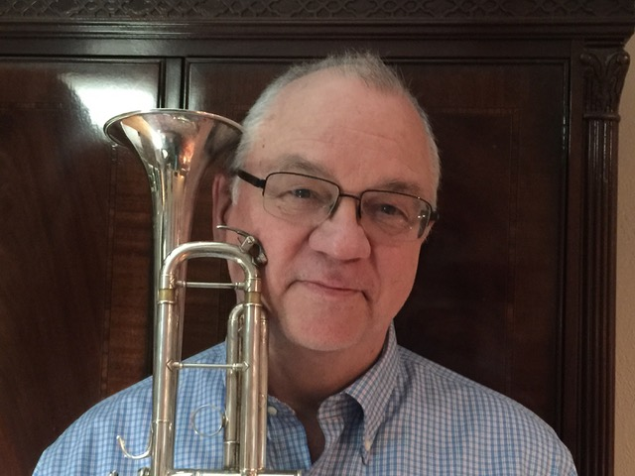
David Bruce Adams
I have had the great pleasure of performing with the Monterey County Pops! for over 30 years, and even conducted a concert at the Naval Postgraduate school.
I started playing the trumpet at age 8 under the tutelage of my grandfather and uncle, both professional musicians and music educators. I hold a Bachelor of Music degree from Boston University, where I studied with Roger Voisin, Principal Trumpet of the Boston Symphony. My Master’s Degree is from San Jose State, and I had a Music Fellowship at Northwestern University. My teaching career (bands, jazz bands, orchestra), which included all grade levels, began in Leicester, MA, continued in Cupertino, CA, and was capped off by many years at Palo Alto High School and Foothill College. Though now retired from full-time teaching after more than 40 years, I am in my 30th year as Music Director of Foothill Symphonic Winds, a wonderful adult community band. I also adjudicate music festivals all over Northern California.
My love affair with music all started with the trumpet, and I am grateful for all the wonderful and diverse professional opportunities that have come my way over the years. A partial list: Newton (MA) Symphony, San Jose Symphony, American Musical Theatre, San Francisco Wind Ensemble, Natalie Cole, The Temptations, Manhattan Transfer, Roberta Flack, Johnny Mathis, Opera San Jose, Oakland Raiders Band, 49ers Band, Joe Smiell Bavarian Band, Mission Peak Brass Band, Altos Brass.

David Bruce Adams
Music Director, Foothill Symphonic Winds
www.fswinds.org
https://www.facebook.com/FoothillSymphonicWinds

