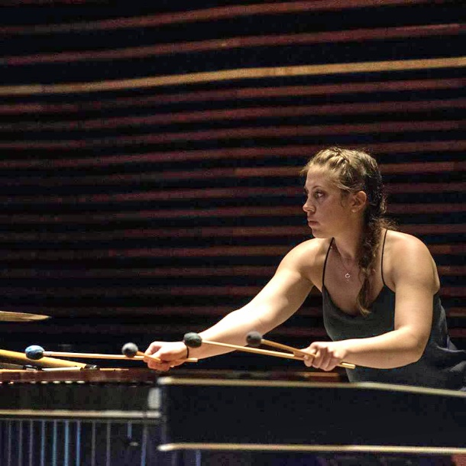
Brietta Greger is a Bay Area percussionist with a Bachelor of Music from Chapman University and a Master of Fine Arts from California Institute of the Arts. She specializes in avant-garde classical chamber music, hand drums including North Indian classical tabla, riq, congas, and pandeiro, and musical theater shows. A composer, improviser, recording artist, and teacher, Brietta can be found performing with Nueva Big Band, Will Rees Band, and in musical theaters around the Bay Area. She teaches at Monticello Academy and the Rhythm Academy and has recorded and toured with Cellista for her albums Transfigurations, Rage, and Pariah.

Website: briettagreger.com
Email: brietta.greger@gmail.com

