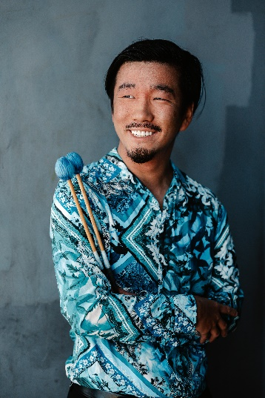

Shota Otaguro is a multi-talented percussionist based in San Jose, California. He earned a Bachelor’s degree in Music Performance from San Jose State University under the guidance of Galen Lemmon, specializing in classical, orchestral, and contemporary percussion.

As a member of the San Francisco Brass Band, he achieved first place in the solo percussion category at the 2023 North American Brass Band Association, while the San Francisco Brass band also secured the top spot in their class. In 2019, he won the Fremont Symphony’s Young Artist Competition and the SJSU concerto competition, while also securing first place in California’s PAS competitive festival’s collegiate solo marimba category in 2018.

With a passion for music education, Shota currently conducts the San Jose Youth Symphony’s Percussion ensemble, introducing young musicians to a diverse repertoire of contemporary and classical pieces, including his own compositions and arrangements.

Shota also is the percussion coordinator for the Monta Vista High School music program. There, he arranges percussion parts and serves as the percussion caption head during the fall marching band season. During the winter, he designs, composes, and directs the winter percussion program, enhancing the educational experience for students.

